**Project Report Format**

1. **INTRODUCTION**
   1. Project Overview
   2. Purpose
2. **LITERATURE SURVEY**
   1. Existing problem
   2. References
   3. Problem Statement Definition
3. **IDEATION & PROPOSED SOLUTION**
   1. Empathy Map Canvas
   2. Ideation & Brainstorming
   3. Proposed Solution
   4. Problem Solution fit
4. **REQUIREMENT ANALYSIS**
   1. Functional requirement
   2. Non-Functional requirements
5. **PROJECT DESIGN**
   1. Data Flow Diagrams
   2. Solution & Technical Architecture
   3. User Stories
6. **PROJECT PLANNING & SCHEDULING**
   1. Sprint Planning & Estimation
   2. Sprint Delivery Schedule
   3. Reports from JIRA
7. **CODING & SOLUTIONING (Explain the features added in the project along with code)**
   1. Feature 1
   2. Feature 2
   3. Database Schema (if Applicable)
8. **TESTING** 
   1. Test Cases
   2. User Acceptance Testing
9. **RESULTS**
   1. Performance Metrics
10. **ADVANTAGES & DISADVANTAGES**
11. **CONCLUSION**
12. **FUTURE SCOPE**
13. **APPENDIX**

Source Code

GitHub & Project Demo Link

Introduction

Project Overview

User is buy the product online by chatbot instead of keyboard search.Keeyboard Search Is not all time recommends correct product.Chatbot is normally recoomends the product by user interest.The keyboard may not recoomend the product user interest.The chat also manage the order details in the project.It is very easy the user is to order without any worry about.The user is only focus on the product not all other things in the website.The user is login the webpage.After the dashboard page is shows the dress.In the side the chatbot is here.The chatbot is use the user order the product.The is user selected.The chatbot is sent the mail to user email.Chatbot is send the notification when the product is arrived in the user location.The admin is login the website then the admin dashboard is open.The admin dashboard is gives the user product.The admin can view the user details.The admin dashboard have the update stock.The admin can update the stock using to update the stock.The website use the external chatbot.the chatbot are IBM Watson Assistance.The Website store data at the cloud databse.the database are IBM DB2.It is sql based database.The Website is upload the project in the cloud.It the project is accessed using the IBM Object Storage.The Object storage is use bucket to store the project.The website use the container.The container is Docker.It is used to upload the project to the cloud.The user is click the website to manage the massive amount of user.

Purpose:

Users to buy product to chatbot.It is very easy the user is use the website.

User can manage the order by chatbot.User can display the product by the user interest.

User can find the product with less time.

LITERATURE SURVEY

2.1 Exsisting Problem

|  |  |  |  |
| --- | --- | --- | --- |
| Title | Year | Technology | Problem |
| Outfit Recommender System | 2018 | E-Commerce,  Collaborative filtering,Cloud Computing EngCine,Python,html. | Grey-sheep problem refers to users with unique preferences and tastes that make it difficult to develop accurate profiles. |
| Clothing fashion Recommendation system | 2020 | Singular value Decomposition method,Azure ML Studio,Collaborative filtering. | Some offer up too many lowest common denominator recommendation artificially. |
| Image base fashion recommender system | 2021 | Cross domain recommendation system,Flask,DevOps,Html,Css | Some don’t support the long tail enough and just recommend obivious items,outliers can be a problem. |
| Modern Fashion recommender system | 2022 | AWS,Docker,Artificial Intelligence,python,google cloud computing engine. | Inaccurately estimate consumer’s true preference stand to pull down willingness to pay for some items and increase of the likehood of actual it. |

2.2 References

[1] Mohamed Elleuch, Anis Mezghani, Mariem Khemakhem, Monji Kherallah “Clothing Classification using Deep CNN Architecture based on Transfer Learning” ,2021 DOI:10.1007/978-3-030-49336-3_24 [2] Saurabh Gupta, Siddartha Agarwal, Apoorve Dave. “Apparel Classifier and Recommender using Deep Learning.” (2015). [3] Bossard, Lukas, Matthias Dantone, Christian Leistner, Christian Wengert, Till Quack and Luc Van Gool. “Apparel Classification with Style.” ACCV (2012). [4] Krizhevsky, Alex, Ilya Sutskever and Geoffrey E. Hinton. “ImageNet classification with deep convolutional neural networks.” Communications of the ACM 60 (2012): 84 - 90. [5] Congying Guan, Shengfeng Qin, Yang Long, (2019) \"Apparel-based deep learning system design for apparel style recommendation\", International Journal of Clothing Science and Technology. [6] Stephen Marsland, ?Machine Learning – An Algorithmic Perspective?, Second Edition, Chapman and Hall/CRC Machine Learning and Pattern Recognition Series, 20

2.3 Problem Definition Statement

User is enter the wrong keyword to search keyboard it is recommend wrong product.

Users is give the option to the chatbot to recommend the correct product.

Ideation and Proposed Solution

3.1 Empathy map & Canvas

Empathy Map Canvas: An empathy map is a simple, easy-to-digest visual that captures knowledge about a user’s behaviours and attitudes. It is a useful tool to helps teams better understand their users. Creating an effective solution requires understanding the true problem and the person who is experiencing it. The exercise of creating the map helps participants consider things from the user’s perspective along with his or her goals and challenges.

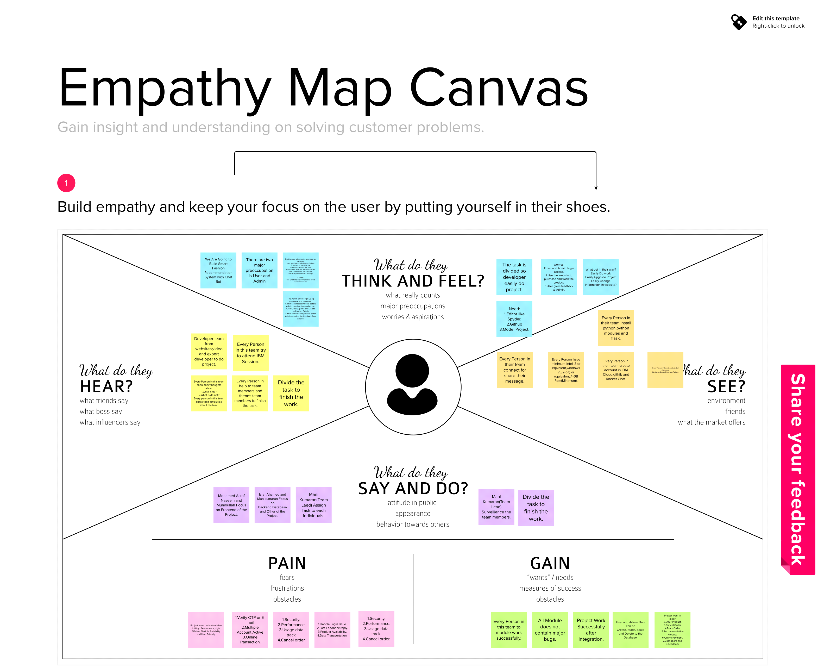

Reference: <https://app.mural.co/invitation/mural/ibmproject0250/1663489514513?sender=u11a15f7b9d6bacf44a890331&key=9537ddbf-520c-44a0-8c57-37939aba8c63>

3.2 Brainstorm & Ideation

Brainstorming provides a free and open environment that encourages everyone within a team to participate in the creative thinking process that leads to problem solving. Prioritizing volume over value, out-of-the-box ideas are welcome and built upon, and all participants are encouraged to collaborate, helping each other develop a rich amount of creative solutions. Use this template in your own brainstorming sessions so your team can unleash their imagination and start shaping concepts even if you're not sitting in the same room

Reference: https://app.mural.co/t/ibmproject0250/m/ibmproject0250/1668146454106/db7d236756f3 2bba505a2712c7ba94299cc51e2e?sender=ud60e8640702a4e97caed3020

**Step-1: Team Gathering, Collaboration and Select the Problem Statement**

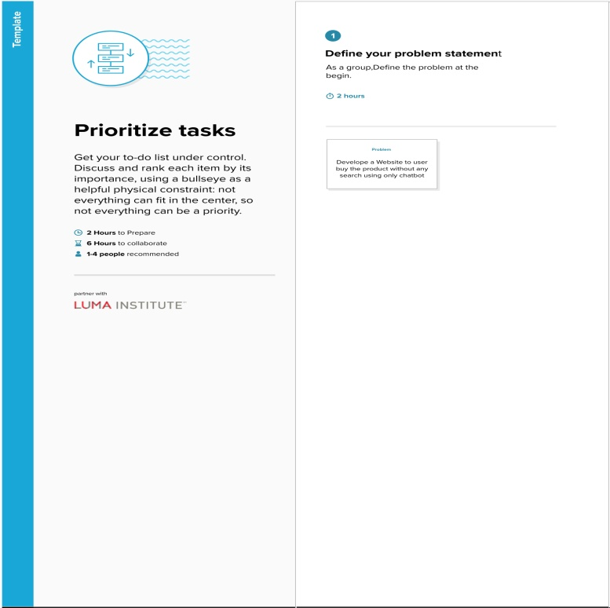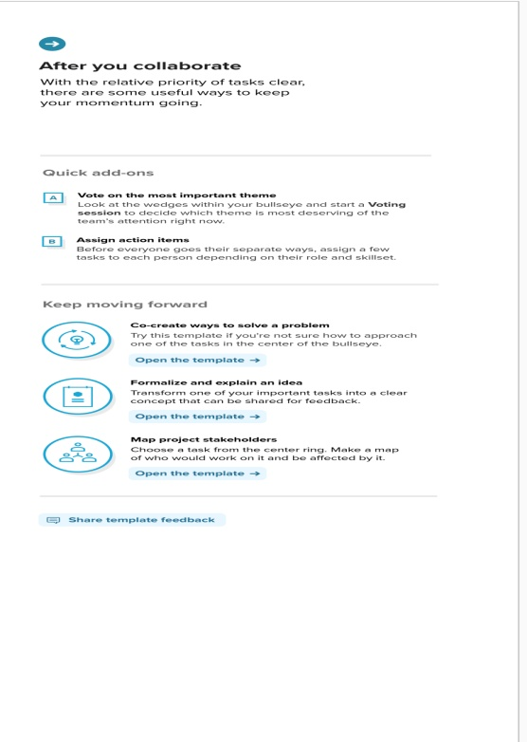

**Step-2: Brainstorm, Idea Listing and Grouping**

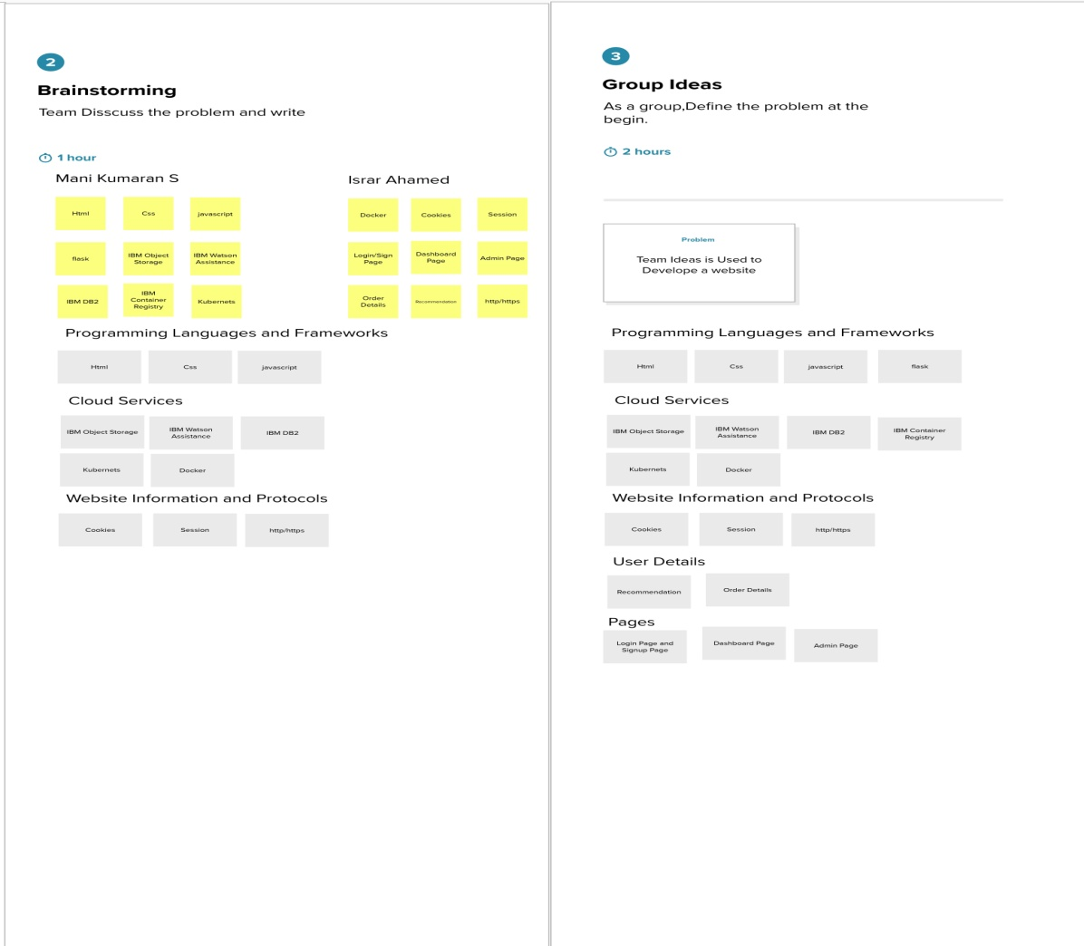

**Step-3: Idea Prioritization**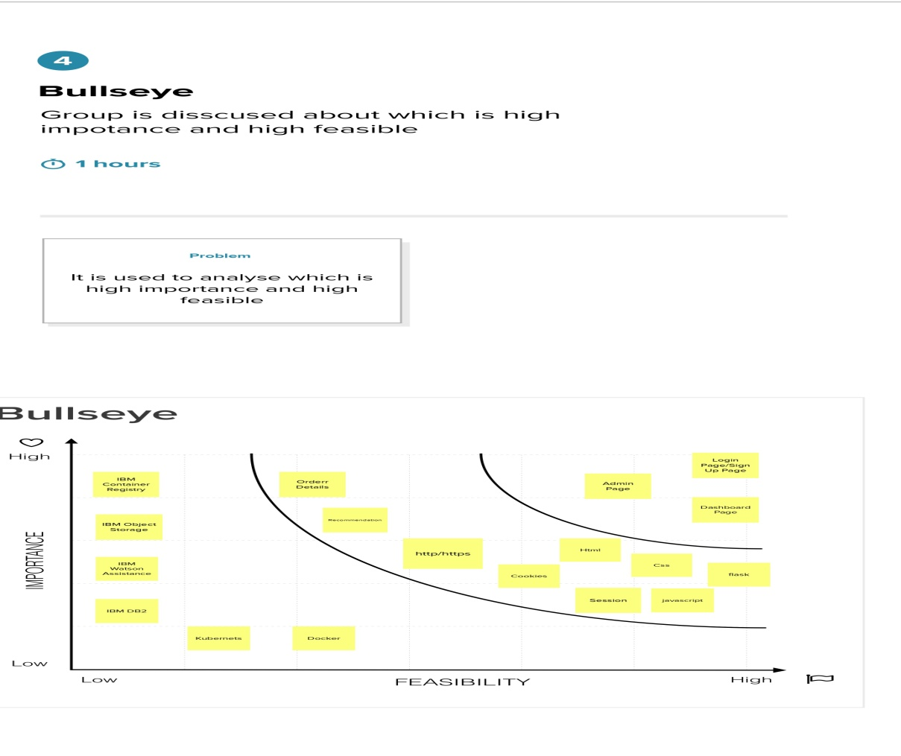

**3.3 Proposed Solution**

Project team shall fill the following information in proposed solution template

|  |  |  |
| --- | --- | --- |
| **S.No.** | **Parameter** | **Description** |
| 1. | Problem Statement (Problem to be solved) | Many of the website is use a keyboard search for searching the correct product.The customer is type the wrong word it would recommend wrong product.It is major problem most of the  online purchasing website. |
| 2. | Idea / Solution description | We have a chatbot it is choose the option to  display the product by the recommendation the correct product. |
| 3. | Novelty / Uniqueness | It Provides the correct product in the online purchasing website.  Customer can find the product using the recommendation. |
| 4. | Social Impact / Customer Satisfaction | Customer can easily to find the product using chatbot. |
| 5. | Business Model (Revenue Model) | It provide more sales because that gives the good result.The website display ads and  purchase get the commission. |
| 6. | Scalability of the Solution | At starting it is website and after we develop to application for all platform. |

3.4 Proposed Solution Fit

The Problem-Solution Fit simply means that you have found a problem with your customer and that the solution you have realized for it actually solves the customer’s problem. It helps entrepreneurs, marketers and corporate innovators identify behavioral patterns and recognize what would work and why.

Purpose:

* Solve complex problems in a way that fits the state of your customers.
* Succeed faster and increase your solution adoption by tapping into existing mediums and channels of behavior.
* Sharpen your communication and marketing strategy with the right triggers and messaging.
* Increase touch-points with your company by finding the right problem-behavior fit and building trust by solving frequent annoyances, or urgent or costly problems.
* Understand the existing situation in order to improve it for your target group

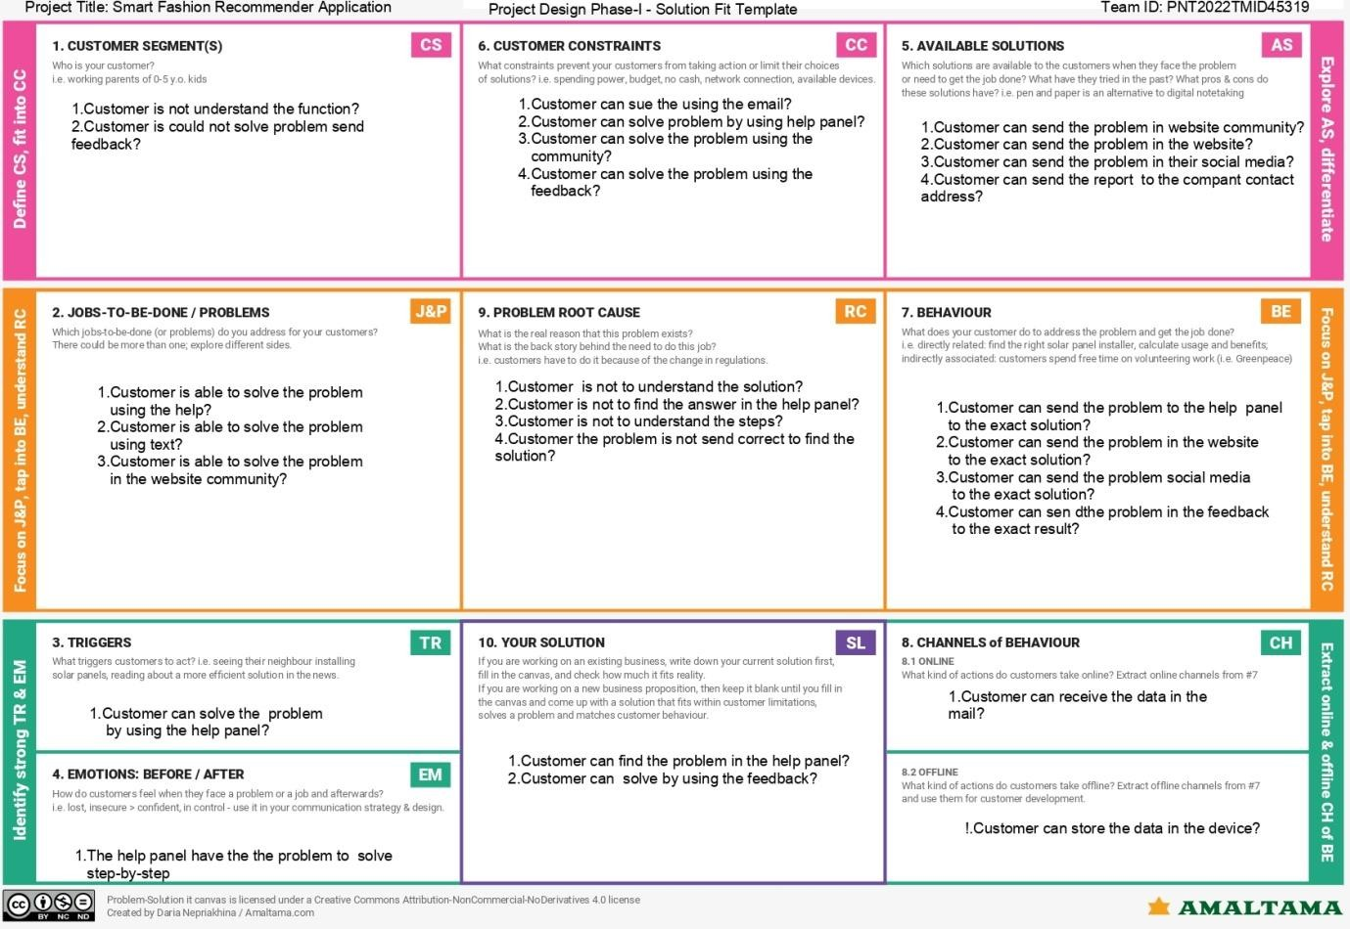 References:

1. https://gustdebacker.com/problem-solution- fit/#:~:text=What%20is%20a,the%20customer%E2%80%99s%20problem.
2. https://[www.feedough.com/problem-solution-](http://www.feedough.com/problem-solution-) fit/#:~:text=Why%20Achieving%20A,guessing%20their%20needs.

4.Requirement Analysis

4.1 Functional Requirements

Following are the functional requirements of the proposed solution.

|  |  |  |
| --- | --- | --- |
| **FR No.** | **Functional Requirement (Epic)** | **Sub Requirement (Story / Sub-Task)** |
| FR-1 | User Registration | Registration through Form |
| FR-2 | User Interaction | Interact through the Chat Bot |
| FR-3 | Buying Products | Through the chat Bot Recommendation |
| FR-4 | Track Products | Ask the Chat Bot to Track my Orders |
| FR-5 | Return Products | Through the chat Bot |
| FR_6 | New Collections | Recommended from chat Bot |

4.2 Non Functional Requirements

Following are the non-functional requirements of the proposed solution.

|  |  |  |
| --- | --- | --- |
| **FR No.** | **Non-Functional Requirement** | **Description** |
| NFR-1 | **Usability** | Using Android or IOS or windows applications. |
| NFR-2 | **Security** | The user data is stored securely in IBM cloud. |
| NFR-3 | **Reliability** | The Quality of the services are trusted. |
| NFR-4 | **Performance** | Its Provide smooth user experience. |
| NFR-5 | **Availability** | The services are available for 24/7. |
| NFR-6 | **Scalability** | Its easy to scalable size of users and products. |

5.Project Design

5.1 Data Flow Diagrams

# Data Flow Diagrams:

A Data Flow Diagram (DFD) is a traditional visual representation of the information flows within a system. A neat and clear DFD can depict the right amount of the system requirement graphically. It shows how data enters and leaves the system, what changes the information, and where data is stored.

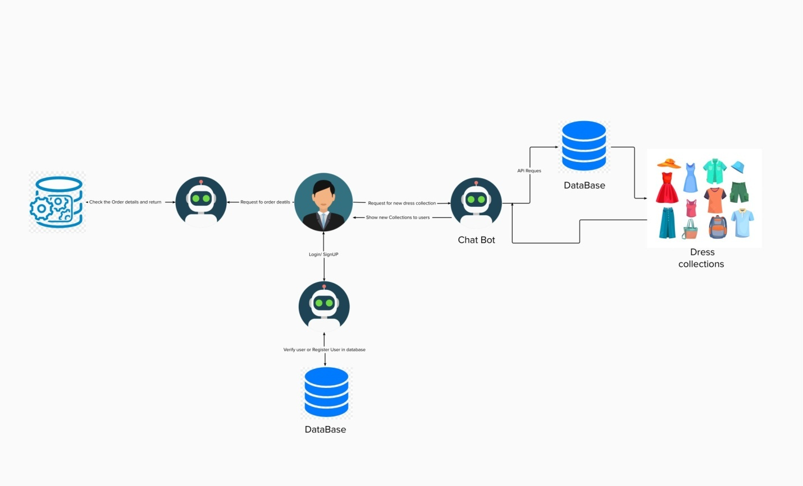

5.2 Solution & Technical Architecture

Solution Architecture:

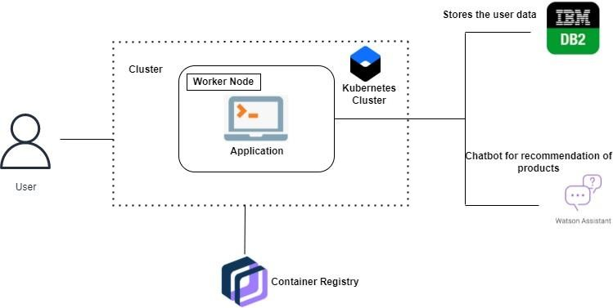

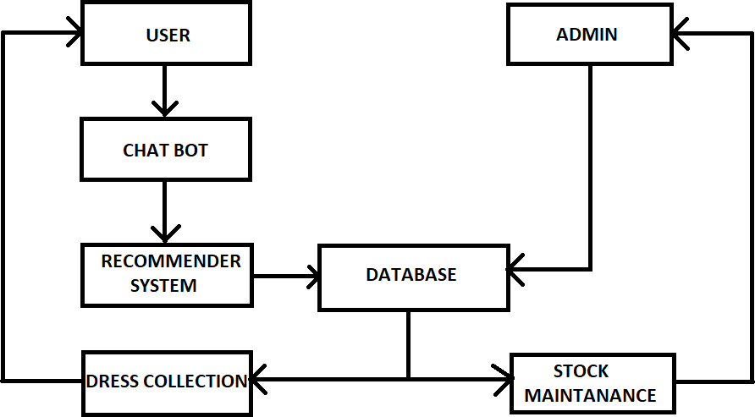

|  |  |  |  |  |  |  |
| --- | --- | --- | --- | --- | --- | --- |
| Spirint | Functional Requirement(Epic) | User Story Number | User Story/Task | Story Points | Priority | Team Members |
| Spirint-1 | User Panel | USN-1 | The User will login into the website and go through the products available on the website | 20 | High | 1.MANIKUMARAN S  2.ISRAR AHAMED M  3.MOHAMED ASRAF NASEEM S  4.MUHIBULLA M |
| Spirint-2 | Admin Panel | USN-2 | The role of the admin is to check out the database about the stock and have a track of all the things that the users are purchasing. | 20 | High | 1.MANIKUMARAN S  2.ISRAR AHAMED M  3.MOHAMED ASRAF NASEEM S  4.MUHIBULLA M |
| Spirint-3 | Chat Bot | USN-3 | The User can directly talk to Chatbot regarding the products.Get the recommendations based on information provided by the user. | 20 | High | 1.MANIKUMARAN S 2.ISRAR AHAMED M 3.MOAHMED ASRAF NASEEM S  4.MUHIBULLA M |
| Spirint-4 | Final delivery | USN-4 | Container of applications using docker kubernets and deployment the application.Create thedocumentation and final submit the application | 20 | High | 1.MANIKUMARAN S  2.ISRAR AHAMED M  3.MOHAMED ASRAF NASEEM S  4.MUHIBULLA M |

5.3 User Stories

6.Project Planning & Scheduling

6.1 Spirint Planning & Estimation

|  |  |  |  |  |  |  |
| --- | --- | --- | --- | --- | --- | --- |
| Spirint | Functional Requirement(Epic) | User Story Number | User Story/Task | Story Points | Priority | Team Members |
| Spirint-1 | User Panel | USN-1 | The User will login into the website and go through the products available on the website | 20 | High | 1.MANIKUMARAN S  2.ISRAR AHAMED M  3.MOHAMED ASRAF NASEEM S  4.MUHIBULLA M |
| Spirint-2 | Admin Panel | USN-2 | The role of the admin is to check out the database about the stock and have a track of all the things that the users are purchasing. | 20 | High | 1.MANIKUMARAN S  2.ISRAR AHAMED M  3.MOHAMED ASRAF NASEEM S  4.MUHIBULLA M |
| Spirint-3 | Chat Bot | USN-3 | The User can directly talk to Chatbot regarding the products.Get the recommendations based on information provided by the user. | 20 | High | 1.MANIKUMARAN S 2.ISRAR AHAMED M 3.MOAHMED ASRAF NASEEM S  4.MUHIBULLA M |

|  |  |  |  |  |  |  |
| --- | --- | --- | --- | --- | --- | --- |
| Spirint-4 | Final delivery | USN-4 | Container of applications using docker kubernets and deployment the application.Create thedocumentation and final submit the application | 20 | High | 1.MANIKUMARAN S  2.ISRAR AHAMED M  3.MOHAMED ASRAF NASEEM S  4.MUHIBULLA M |

6.2 Sprint Delivery & Schedule

# Project Tracker, Velocity & Burndown Chart: (4 Marks)

|  |  |  |  |  |  |  |
| --- | --- | --- | --- | --- | --- | --- |
| **Sprint** | **Total Story Points** | **Duration** | **Sprint Start Date** | **Sprint End Date (Planned)** | **Story Points**  **Completed (as on Planned End Date)** | **Sprint Release Date**  **(Actual)** |
| Sprint-1 | 20 | 6 Days | 24 Oct 2022 | 29 Oct 2022 |  | 29 Oct 2022 |
| Sprint-2 | 20 | 6 Days | 31 Oct 2022 | 05 Nov 2022 |  | 05 Nov 2022 |
| Sprint-3 | 20 | 6 Days | 07 Nov 2022 | 12 Nov 2022 |  | 12 Nov 2022 |
| Sprint-4 | 20 | 6 Days | 14 Nov 2022 | 19 Nov 2022 |  | 19 Nov 2022 |

# 6.3 Report Jira Files

# Burndown Chart:

